**PYTHON ACTIVITY**

1. Write a program that generates a stream of random numbers and writes them to a file.

**Program:**

import random

with open('p1.txt','w') as file:

for i in range(10):

file.write(str(random.randint(1,100)))

file.write("\n")

file.close()

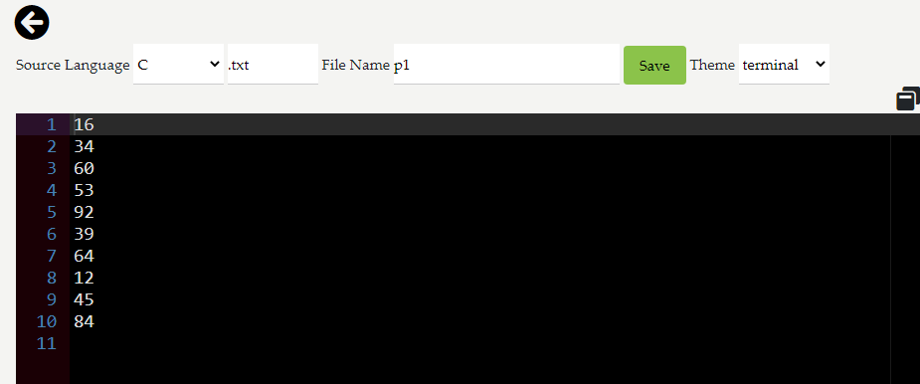**Output:**

2. Write a program to read the random numbers from the file created above and calculate their average.

**Program:**

av=0

with open('p1.txt','r') as file:

for i in range(10):

k=file.readline()

av=av+int(k)

print("The Average of all value in the file p1.txt is :",av/10)

file.close()

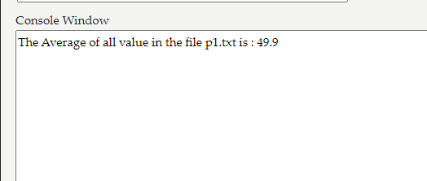**Output:**

3. Write a program that reads from a file and handles the case where the file does not exist.

**Program:**

try:

with open('p2.txt','r') as file:

print(file.read())

except FileNotFoundError as e:

print("Error! ",e)

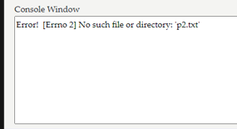**Output:**

4. Create a user-defined exception NegativeNumberError that is raised when a negative number is encountered in a list.

**Program:**

def NegativeNumberError(num):

return f"Negative number encountered: {num}"

def check(n):

if n < 0:

raise ValueError(NegativeNumberError(n))

return "All numbers are non-negative."

num=int(input("Enter a number : "))

try:

result = check(num)

print(result)

except ValueError as e:

print(e)

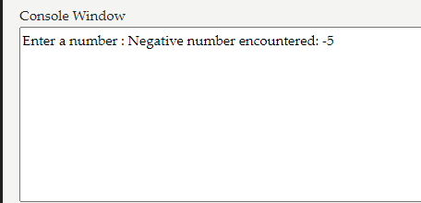**Output:**

5. Create a NumPy array of 10 random numbers and print them.

import random

import numpy as np

l=[]

for i in range(10):

k=random.randint(1,20)

l.append(k)

print(np.array(l))

**Program:**

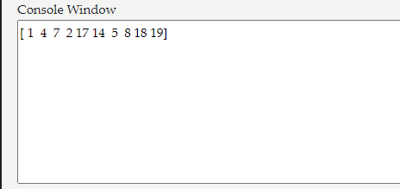**Output:**

6. Write a program to add and remove items from a NumPy array.

**Program:**

import numpy as np

import random

l=[]

for i in range(10):

k=random.randint(1,20)

l.append(k)

n=np.array(l)

print(n)

while True:

print("1.add\n2.remove\n3.Exit")

p=int(input("Enter a number "))

if p==3:

break

elif p==1:

k=int(input("Enter a number to add :"))

print(np.append(n,k))

elif p==2:

k=int(input("Enter a number to remove :"))

print(np.delete(n,k))

**Output:**

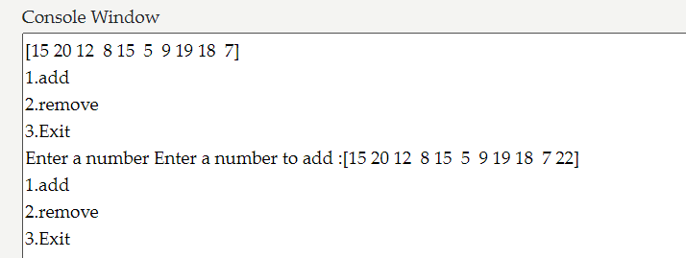**Add element:**

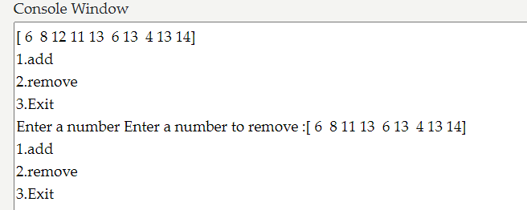**Delete element:**

7. Sort the NumPy array which you created.

**Program:**

import random

import numpy as np

l=[]

for i in range(10):

k=random.randint(1,20)

l.append(k)

m=np.array(l)

print(m)

print(np.sort(m))

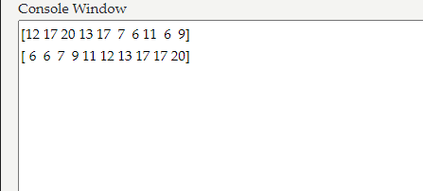**Output:**

8. Reshape a NumPy array into a 2x5 matrix.

**Program:**

import random

import numpy as np

l=[]

for i in range(10):

k=random.randint(1,20)

l.append(k)

m=np.array(l)

print("Normal Array :\n",m)

print("The reshape of the array is:\n",m.reshape(2,5))

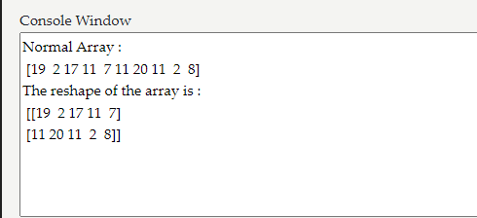**Output:**

9. Demonstrate indexing and slicing on the reshaped matrix.

**Program:**

import random

import numpy as np

l=[]

for i in range(10):

k=random.randint(1,20)

l.append(k)

m=np.array(l)

print("Normal array is : ",m)

f=m.reshape(2,5)

print("Sorted array is : \n",f)

print("Slicing of the array:")

print("Specific Value ",f[1,2])

print("Range of Value ",f[0:2:4])

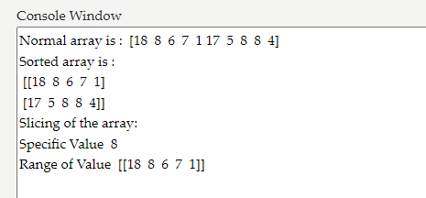**Output:**

10. Write a program to append new data to an existing file and then read the updated file.

**Program:**

k=int(input("Enter a number to add :"))

with open('p1.txt','a') as f:

f.write(str(k)+'\n')

print()

f.close()

with open('p1.txt','r') as q:

p=q.read()

l=p.split('\n')

print(l[:(len(l)-2)])

q.close()

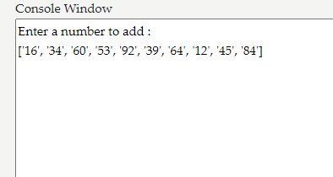**Output:**